Program REport
New Jersey Natural Gas Multi-Family Program Evaluation –
Program Year 1
NJNG
Date: January 12, 2023

Table of contents
Abstract iii
Executive summary iv
1 Introduction 1
1.1 Program design and implementation 1
2 Process Evaluation 2
2.1 Program goals 2
2.2 Program staff interviews 2
2.2.1 Program delivery 2
2.2.2 Program design and processes 2
2.2.3 Tracking metrics and performance 3
2.2.4 Challenges and opportunities 3
3 Impact evaluation 4
4 Evaluability assessment 5
4.1 Boilers 5
4.2 Furnaces 5
4.3 Standalone storage water heaters 6
4.4 Instantaneous gas water heaters 6
4.5 Program data assessment 7
5 Program comparisons 8
6 CONCLUSIONS and Recommendations 9

List of tables
Table 2-1 MF program estimated Participation and Savings triennial goals 2
Table 4-1 MF program data assessment 7
Table 5-1 MF and similar programs from other states, Process findings 8
Table 5-2 MF and similar programs from other states, Impact findings 8

Abstract
DNV conducted a process evaluation and an evaluability assessment for the Multi-family (MF) program.

Findings
The MF program did not have any claimed savings in PY1. Therefore, there are no impact-related findings. However, four MF Home Performance with Energy Star projects are currently in the pipeline, consisting of 756 residential units.
The process evaluation findings indicate that several factors impacted participation, depending on the pathway, including;
- Home Performance with Energy Star (HPwES)
  - Availability of equipment and labor shortages have impacted the HPwES pathway
- Direct Install (DI)
  - Slower implementation times have impacted the DI pathway
- Prescriptive/Custom
  - Long project development timelines and equipment shortages impacted the Prescriptive/Custom pathway
- Engineered Solutions
  - Projects are often very large and complex in nature, leading to longer development times. Delays in equipment acquisition have also impacted this pathway.
Additionally, the complexity of building ownership within the MF program was identified as impacting participation in PY1, particularly around financing. There are often multiple entities (on the customer side) that are involved in the review and approval process, which can create delays in the overall process.
The evaluability assessment determined what data points would need to be collected at the time of implementation to allow for an effective evaluation of the following measure types:
- Boilers
- Standalone storage water heaters
- Instantaneous gas water heaters
DNV also summarized the required standard program data needed to evaluate the Engineered Solutions program.

Recommendations
Process Evaluation:
- Continue to invest in the recruitment of projects. The long lead times for these projects will allow the MF program to achieve its triennium goal.
- Conduct nonparticipant research to investigate reasons for any nonparticipation, focusing on customers who received program marketing but chose not to participate. Investigate how each pathway performs against the set goals, including the effectiveness of delivery channels and program partners.
Impact Evaluation: As program participation in PY2 increases and measures are selected for customers, the evaluator encourages NJNG to discuss proposed engineering approaches, particularly for more complex custom measures.
Evaluability Assessment: The required standard program data that will be needed to evaluate the MF program are: Participant, Program Dates, Baseline Equipment, Partner Utility Data, Subcontractor Data, Recommended Measures, Installed Measures, Installed Measure Characteristics, Job Cost, and Energy Savings.

Executive summary

Summary of methods
Process evaluation: In June 2022, DNV conducted in-depth interviews with program staff to learn more about the history and context of its programs, program design and processes, and challenges and opportunities. These interviews included speaking with the Director of SAVEGREEN, Energy Efficiency Commercial & Residential Program Supervisors.
Impact evaluation: Due to no claimed savings in Year 1, no impact evaluation activities were conducted for the Multi-family (MF) program.
Evaluability assessment: For programs with limited or no participation, DNV conducted an evaluability assessment. This assessment included a review of the anticipated common measure types within the program, and the team recommended best practices for information and data points that should be collected at the time of implementation to allow for an effective evaluation.

Results and recommendations

Process evaluation
- The MF program had no claimed savings in Program Year 1. Participation was impacted by several factors, depending on the pathway, including;
  - Home Performance with Energy Star (HPwES)
    - Availability of equipment and labor shortages have impacted the HPwES pathway
  - Direct Install (DI)
    - Slower implementation times have impacted the DI pathway
  - Prescriptive/Custom
    - Long project development timelines and equipment shortages impacted the Prescriptive/Custom pathway
  - Engineered Solutions
    - Projects are often very large and complex in nature, leading to longer development times. Delays in equipment acquisition have also impacted this pathway.
- Recommendation: Continue to invest in the recruitment of projects. The long lead times for these projects will allow the MF program to achieve its triennium goal.
- Recommendation: Conduct nonparticipant research to investigate reasons for any nonparticipation, focusing on customers who received program marketing but chose not to participate. Investigate how each pathway performs against the set goals, including the effectiveness of delivery channels and program partners.
Impact evaluation
- As there were no claimed savings, no impact findings are presented here.
- Recommendation: Before project completion, the evaluator encourages NJNG to discuss proposed engineering approaches for PY2 projects with the evaluation team, particularly for more complex and large projects.

Evaluability assessment
The evaluability assessment analyzed which data points should be collected at the time of implementation to allow for an effective evaluation of three categories and the algorithms that will be used to estimate savings. The algorithms are listed here:
Standalone storage water heaters: Fuel Savings (MMBtu/yr) = ((1 – (EFF_{b} / EFF_{q}) + SLF⁴⁹) * Energy Use Density * Area / 1000 kBtu/MMBtu
Instantaneous gas water heaters: Fuel Savings (MMBtu/yr) = ((1 – (EFF_{b} / EFF_{q}) + SLF⁵⁰) * Energy Use Density * Area
Gas Boilers: Fuel Savings (MMBtu/yr) = Cap_{in} * EFLH_{h} * ((Eff_{q}/Eff_{b})-1) / 1000 kBtu/MMBtu
Gas Furnaces: Fuel Savings (MMBtu/yr) = Capin * EFLHh * ((Effq/Effb)-1) / 1000 kBtu/MMBtu
DNV also analyzed the required standard program data needed to evaluate the MF program, summarized in the following table:
Type | Variables | Use
Participant | Name, address, phone number, email address, account number, business type | Participant surveys
Program Dates | Audit date, job approval date, installation date, work submit date, inspection date, payment date | Process Analysis  Impact Analysis
Baseline Equipment | Baseline efficiency levels, fuel type, system type, system size | TRM Update
Partner Utility Data | Utility name, customer account number | Match to the electric usage data for the billing analysis.
Subcontractor Data | Company name, contact name, phone number, email | Contractor interviews
Recommended Measures | All recommended measures, gas savings, electric savings, demand savings | Missed Opportunities
Installed Measures | Installed measures, gas savings, electric savings demand savings | Impact analysis
Installed Measure Characteristics | Installed efficiency levels, fuel type, system type, system size | TRM Update
Job Cost | Cost for audit and installed measures | Cost-effectiveness
Energy Savings | Annual and lifetime gas savings, annual and lifetime electric savings, demand savings, gas MMBtu savings, electric MMBtu savings, Total Energy Savings | Realization Rate  TRM Updates

Introduction
This report provides the results of impact and process evaluations of New Jersey Natural Gas’s (NJNG) Multi-family program for the Program Year (PY) period beginning July 1, 2021, and ending on June 30, 2022 (PY1).

Program design and implementation
The Multi-Family (MF) program focuses on installing efficiency measures in MF structures with 3 or more residential units. These facilities cover a wide range of structures, from high rises to large garden complexes. NJNG offers incentives to encourage these customers to invest in energy efficiency.
The MF works with each customer to determine and package the best energy savings opportunities based on NJNG's current program offerings (e.g., direct installation of standard energy savings measures, prescriptive equipment replacement, custom retrofit or engineered solutions), with an emphasis to encourage more comprehensive projects wherever possible. Customers begin participation in the MF Program with a screening to identify and develop a project plan. The screening process considers various factors to create a project plan that will deliver a high level of energy savings most cost-effectively. Important factors that are considered include building size, number of units, weatherization/envelope opportunities, etc.
Depending upon the screening results and the customer's interests, a project plan would include direct installation of standard energy-saving measures, incentives for prescriptive equipment replacement, custom retrofit opportunities, or a comprehensive Engineered Solutions project (see Figure 1-1)
Figure 1-1: Diagram of Multifamily program and its pathways
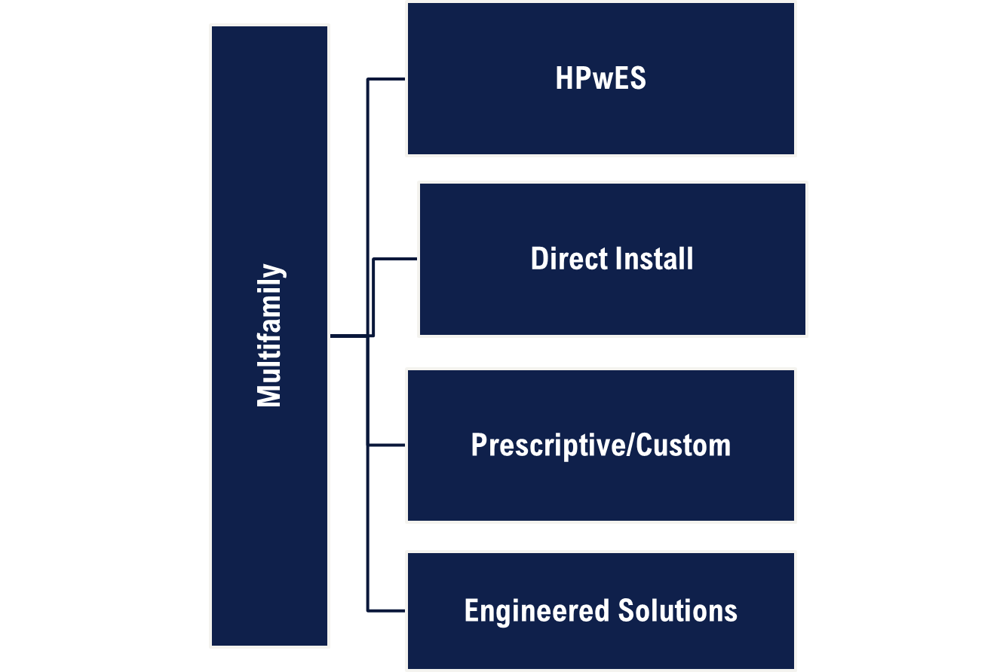

Process Evaluation

Program goals
Per the NJNG’s Annual Progress Report, the MF program did not claim any savings for PY1 but secured customer commitments on four projects. Per the NJNG’s approved Program Plan, the MF program participation and savings goal for PY1 through PY3 are presented in Table 2-1. The program projected a savings of 92,477 therms in PY1 from 1,153 participants4.
Table 2-1 MF program estimated Participation and Savings triennial goals
Metric | Pathway | PY1 | PY2 | PY3
 | HPwES | 375 | 413 | 433
 | Direct Install | 750 | 825 | 866
Estimated Participants | Prescriptive/Custom | 22 | 27 | 32
 | Engineered Solutions | 6 | 8 | 10
 | Total | 1,153 | 1,273 | 1,341
Projected Net Annual Natural Gas Savings (therms) |  | 92,477 | 109,362 | 124,599

Program staff interviews
DNV conducted in-depth interviews with the Director of SAVEGREEN, Energy Efficiency Commercial and Residential Program Supervisors and the Senior Evaluation, Measurement & Verification Specialist as part of this study. We used these interviews to both learn about and document staff perceptions of the following:
- Roles and responsibilities with the programs
- Program design and processes, including marketing and outreach
- Program metrics and performance against goals
- Challenges and opportunities

Program delivery
The NJNG team outreach team has engaged in one-on-one discussions with customers who are interested in learning more about the available program. NJNG was available to accept interested customers into the program for the initial screening and to process incentives for prescriptive measures and/or the MF HPwES pathway. As of the end of PY1, there were four MF HPwES projects in the pipeline, consisting of 756 units.
NJNG also had the infrastructure in place to engage MF property owners in Engineered Solutions. However, no customer applications were submitted during PY1. NJNG conducted a competitive solicitation and selected CLEAResult as a Third-Party Implementation Contractor to support the launch of Direct Install of energy savings measures for the MF program.

Program design and processes
The MF Program works with each customer to determine and package the best energy savings opportunities based on NJNG's current program offerings (e.g., HPwES , direct installation of standard energy savings measures, prescriptive equipment replacement, custom retrofit or engineered solutions), with an emphasis to encourage more comprehensive projects wherever possible. Customers begin participation in the MF Program with a screening survey (see APPENDIX B: NJ Joint Utility Energy Efficiency Program MF Pre-Survey Questionnaire) to identify and develop a project plan. The screening process considers various factors to create a project plan that will deliver a high level of energy savings most cost-effectively. Important factors that are considered include building size, number of units, Area, HVAC/Central Plant details, weatherization/envelope opportunities, etc.
Based on the survey response, HPwES (requires atleast 5 units) or Prescriptive/Custom rebates are offered to the customers for specific pieces of gas consuming equipment. For larger, more complex MF buildings, the Engineered Solutions Program that includes ASHRAE level audits, design, construction administration, commmissioning, and Measurement & Verification services is offered to the customers.

Tracking metrics and performance
The Director explained that NJNG is bound by a June 10, 2020, BPU order to report program metrics within 75 days of the close of the program year. Program years run from July 1 through June 30. This program reporting includes metrics related to energy savings, customer participation, dollars invested, administrative costs, and other defined quantitative performance indicators. The program tracks must also capture multiple technical data points like EFLHh (effective full-load heating hours), efficiencies for Boiler Reset Controls, Boilers, and Furnace measures to ensure the energy savings are properly recorded in accordance with approved Technical Resource Manual calculations (previously referred to as the NJCEP protocols).

Challenges and opportunities
Project staff attributed low participation to several factors, depending on the pathway, including the availability of equipment and labor shortages, slower implementation times, long project development timelines due to the complexity of MF projects.

Impact evaluation
Due to no claimed savings, the Evaluation Team did not complete an impact evaluation for MF program in PY1.

Evaluability assessment
For programs with limited or no participation, DNV conducted an evaluability assessment. This assessment included a review of the anticipated common measure types within the program and provides recommended best practices for information and data points that should be collected at the time of implementation to allow for an effective evaluation.
MF measures include HVAC, motors, lighting, controls, and other building systems, energy efficiency, and energy-consuming equipment. The evaluation team has summarized the required engineering inputs for commonly replaced measures for similar programs below.

Boilers
This measure targets the use of smaller-scale boilers (less than or equal to 4000 MBH) and furnaces (no size limitation) in all commercial facilities. Larger sized boilers are treated under the custom measure path. This measure applies to new construction, replacement of failed equipment, or end of useful life. The following data points would need to be collected and provided in the program tracking data for boilers:
- Cap_{in} = Input capacity of the qualifying unit in kBtu/hr
- EFLH_{h} = The equivalent Full Load Hours of operation for the average unit during the heating season in hours
- Eff_{b} = Boiler Baseline Efficiency
- Eff_{q} = Boiler Proposed (or installed) Efficiency
- 1000 = Conversion from kBtu to MMBtu
- Facility Type
- Boiler Type
- Equipment Size (kBtu/hr)
Savings will be estimated using the following algorithm:
- Fuel Savings (MMBtu/yr) = Cap_{in} * EFLH_{h} * ((Eff_{q}/Eff_{b})-1) / 1000 kBtu/MMBtu

Furnaces
The methodology outlined below shall be adopted for estimating savings for installation of qualifying furnaces. The following data points would need to be collected and provided in the program tracking data for furnaces:
- Cap_{in} = Input capacity of qualifying unit in kBtu/hr
- EFLH_{h} = The Equivalent Full Load Hours of operation for the average unit during the heating season in hours
- Eff_{b} = Furnace Baseline Efficiency
- Eff_{q} = Furnace Proposed Efficiency
- 1000 = Conversion from kBtu to MMBtu
- Facility Type
- Furnace Type (Gas Fired or Oil Fired)
- Equipment Size (kBtu/hr)
Savings will be estimated using the following algorithm:
- Fuel Savings (MMBtu/yr) = Cap_{in} * EFLH_{h} * ((Eff_{q}/Eff_{b})-1) / 1000 kBtu/MMBtu

Standalone storage water heaters
This measure is intended for standalone storage water heaters installed in commercial facilities. The following data points would need to be collected and provided in the program tracking data for standalone storage water heaters:
- EFF_{q} = Efficiency of the qualifying water heater
- EFF_{b} = Efficiency of the baseline water heater, commercial grade
- EF_{b} = Energy Factor of the baseline water heater, commercial grade
- Energy Use Density = Annual baseline water heater energy use per square foot of commercial space served (MMBtu/sq.ft./yr)
- Area = Square feet of building area served by the water heater
- SLF = Standby loss factor for savings of qualifying water heater over baseline
- SL_{b} or _{q} = Standby losses in kBtu/hr of the baseline and qualifying storage water heater, respectively. The baseline standby loss is calculated assuming the baseline water heater has the same input capacity rating as the qualifying unit’s input capacity using ASHRAE equipment performance standards. The qualifying unit’s standby losses are available on the AHRI certificate provided with the application.
- Cap_{q} = Rated input capacity of the qualifying water heater
- Facility Type
- Equipment Size (kBtu/hr)
Where,
- SLF = (SL_{b} – SL_{q}) / Cap_{q}
Savings will be estimated using the following algorithm:
- Fuel Savings (MMBtu/yr) = ((1 – (EFF_{b} / EFF_{q}) + SLF⁴⁹) * Energy Use Density * Area / 1000 kBtu/MMBtu

Instantaneous gas water heaters
This measure is intended for instantaneous water heaters installed in commercial facilities. This measure assumes that the baseline water heater is either a code standalone storage water heater, or a code instantaneous water heater. The following data points would need to be collected and provided in the program tracking data for instantaneous gas water heaters:
- EFF_{q} = Efficiency of the qualifying instantaneous water heater.
- EFF_{b} = Efficiency of the baseline water heater, commercial grade.
- EF_{b} = Efficiency of the baseline water heater, commercial grade.
- SLF = Standby loss factor of the baseline water heater fuel usage. This was calculated from standby loss and input capacity data for commercial water heaters exported from the AHRI database.
- Facility Type
- Equipment Type (Gas Storage Water Heater, Gas Instantaneous Water Heater)
- Equipment Size (kBtu/hr)
- Where,
- SLF = 0.775 × Cap_{q} ^{-0.778}
- Area = Square feet of building area served by the water heater
- Cap_{q} = Rated input capacity of the qualifying water heater
Savings will be estimated using the following algorithm:
- Fuel Savings (MMBtu/yr) = ((1 – (EFF_{b} / EFF_{q}) + SLF⁵⁰) * Energy Use Density * Area

Program data assessment
Additionally, DNV has summarized the required standard program data that will be needed to evaluate the Multifamily program, summarized in Table 4-1.
Table 4-1 MF program data assessment
Type | Variables | Use
Participant | Name, address, phone number, email address, account number, business type | Participant surveys
Program Dates | Audit date, job approval date, installation date, work submit date, inspection date, payment date | Process Analysis  Impact Analysis
Baseline Equipment | Baseline efficiency levels, fuel type, system type, system size | TRM Update
Partner Utility Data | Utility name, customer account number | Match to the electric usage data for the billing analysis.
Subcontractor Data | Company name, contact name, phone number, email | Contractor interviews
Recommended Measures | All recommended measures, gas savings, electric savings, demand savings | Missed Opportunities
Installed Measures | Installed measures, gas savings, electric savings demand savings | Impact analysis
Installed Measure Characteristics | Installed efficiency levels, fuel type, system type, system size | TRM Update
Job Cost | Cost for audit and installed measures | Cost-effectiveness
Energy Savings | Annual and lifetime gas savings, annual and lifetime electric savings, demand savings, gas MMBtu savings, electric MMBtu savings, Total Energy Savings | Realization Rate  TRM Updates

Program comparisons
This section reviews Process and Impact Evaluation findings from a sampling of other MF programs around the country.
Table 5-1 MF and similar programs from other states, Process findings
State/Region | MI* | MI** | IL | OK
PY | 2021 | 2021 | 2019 | 2021
FR | NR | NR | NR | 15%
SP | NR | NR | NR | 0%
NTG | 100% | 100% | 92% | 85%
Participant Count | NR | NR | 17,789 projects (876 participants) | 30 properties (3,063 individual apartments)
Participant Satisfaction | 87% (Satisfied) | 87% (Satisfied) | NR | "Overall, most were satisfied"
Implementation Strategy/Program Design | Direct Install | Direct Install | Direct install & Prescriptive | Direct Install
*Residential MF
** MF income Qualified
Table 5-2 MF and similar programs from other states, Impact findings
State/Region | MI | MI | IL | OK
Total Savings claimed | Reported: 3,324,691 (kWh/year)  2,800,823 (therms/year) | Reported: 8,377,766 (kWh/year)  1,008,498 (therms/year) | Reported: 15,436,840 (kWh/year) | Reported: 4,256,383 (kWh/year)
Energy Realization Rate (RR) | Electric-84.03%  Gas- 67.37% | Electric-99.31%  Gas-99.95% | 99% | 102%
Demand Realization Rate (RR) | 87.77% | 99.28% | 100% | 99%
Implementation Strategy/Program Design | Direct Install | Direct Install | Direct install & Prescriptive | Direct Install
Measure Mix | Lighting, Showerheads, Faucet Aerators, Pipe Insulation | Lighting, Showerheads, Faucet Aerators, Pipe Insulation | Lighting, Hot water, Consumer Electronics, HVAC, Refrigeration | HVAC, Building Envelope, Lighting, Domestic Hot water, Appliances
Savings Methodology | TRM Deemed | TRM Deemed | TRM Deemed | TRM Deemed

CONCLUSIONS and Recommendations
Process evaluation
- The MF program had no claimed savings in Program Year 1. Participation was impacted by several factors, depending on the pathway, including;
  - Home Performance with Energy Star (HPwES)
    - Availability of equipment and labor shortages have impacted the HPwES pathway
  - Direct Install (DI)
    - Slower implementation times have impacted the DI pathway
  - Prescriptive/Custom
    - Long project development timelines and equipment shortages impacted the Prescriptive/Custom pathway
  - Engineered Solutions
    - Projects are often very large and complex in nature, leading to longer development times. Delays in equipment acquisition have also impacted this pathway.
- Recommendation: Continue to invest in the recruitment of projects. The long lead times for these projects will allow the MF program to achieve its triennium goal.
- Recommendation: Conduct nonparticipant research to investigate reasons for any nonparticipation, focusing on customers who received program marketing but chose not to participate. Investigate how each pathway performs against the set goals, including the effectiveness of delivery channels and program partners.
Impact evaluation
- As there were no claimed savings, no impact findings are presented here.
- Recommendation: Before project completion, the evaluator encourages NJNG to discuss proposed engineering approaches for PY2 projects with the evaluation team, particularly for more complex and large projects.

APPENDIX A: PROGRAM STAFF FEEDBACK

General Information
- Can you explain what your role and responsibilities are for this program and also of your company?
- Is there anything in particular you are interested in having the evaluators study?

Communication and Structure
- [If not already mentioned] What are the goals of the program? How are they set? [PROBE: segment targets, measure targets, energy efficiency savings, geographic targets, customer satisfaction, etc.]
- What metrics do you use to measure the success of the program?
  - Are there any metrics you would like to see incorporated into measuring and reporting on this program?
- How is the program currently progressing against its goals? How have they performed historically?
  - Are you considering any revision to program goals?
- How are program tracking metrics shared? What is the frequency and format of this reporting?
- What data tracking systems are used for tracking program outreach? Participation? Savings? Project status? How are those integrated, if at all?
- How, if at all, has the COVID-19 pandemic affected participation in the program? (PROBE: Effects on participation, marketing, deployment of program specifics, events/engagement)

Program Process
- [FOR REBATES] Can you describe the participation process for the program from the customer’s perspective, from first contact through rebate payment (or program completion)? At what stage of participation/customer decision making do you typically get involved?
- Have you received any feedback on the participation process from customers?
- How do you decide what energy savings measures are included in the program?
- What other measures, if any, have you thought about including in the program?

Marketing and Outreach
- How is the program currently marketed? What types of outreach activities does your team do?
- Do you conduct any community outreach or engagement? What do you do? [PROBES: how do they elicit input, WHO do they elicit it from, do they make any special efforts to engage LI or minorities (certain programs target LI customers)?]
- How do you measure/judge the effectiveness of program marketing? What metrics does the team capture and how are they used? Do you have specific goals?
- Is there any cross marketing between other programs?
- What do you believe are the most persuasive marketing messages/themes for your program? How is this different for different customers and measures?
- Is there a particular time/event that is the most effective moment to market your program? How is this different for different customers and measures?

Barriers to participation
- What do you see as some of the main barriers to getting a customer to participate in the program?
  - Do you have any plans on how to address these barriers?

Opportunities
- Are there any interesting trends you’ve encountered in how the program is implemented, or what kinds of feedback customers provide about their experience?
- Do you see other opportunities for program growth? If there was one thing you would add or change about the program, what would it be?

APPENDIX B: NJ Joint Utility Energy Efficiency Program MF Pre-Survey Questionnaire
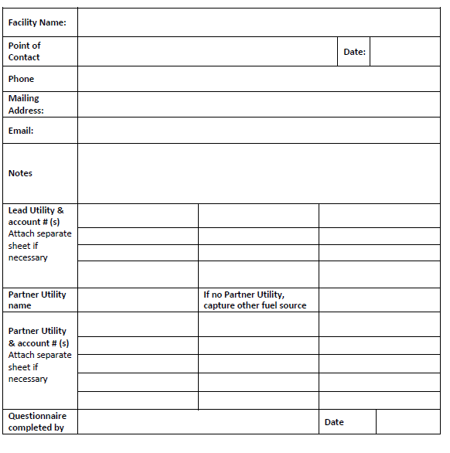

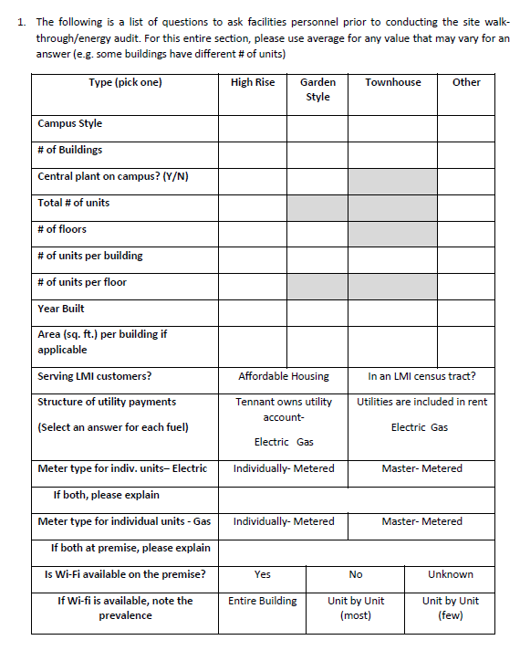

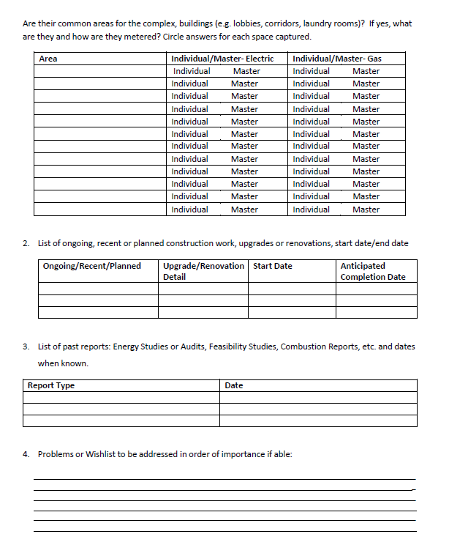

Demand savings are not defined for gas (therm) projects.
https://www.njcleanenergy.com/files/file/UTILITY%20REPORTING/4Q%20FY22/NJNG%20-%20NJ%20Annual%20Report-Executive%20Summary%20-%2010_17_22.pdf
The SAVEGREEN Project Program Plan (NJNG) -12/21/2020 (approved in 3/22.
For HPwES it is the count of completed projects: For DI it is the count of completed projects; For Prescriptive/Custom and Engineered Solutions, it is the count based on number of applications/projects completed not account number
For PY1 filing, the utilities have been given an extension of 30 days and the annual progress report was filed on October 17, 2022.
Demand savings are not defined for gas (therm) projects.

