Inside SoCal Edison’s Plan to Open Its Grid to Distributed Energy

A groundbreaking, just-filed blueprint to bring distributed solar, batteries, EVs and more into billion-dollar grid investment plans

Jeff St. John
July 1, 2015
Two years ago, California told its three big investor-owned utilities to do something they’ve never done before -- make distributed energy resources (DERs for short) a fundamental part of their billion-dollar distribution grid investment plans.
Under state law AB 327, Southern California Edison, Pacific Gas & Electric and San Diego Gas & Electric were tasked with finding a way to integrate solar PV, behind-the-meter batteries, electric vehicle chargers, building energy management systems, and other distributed energy resources into a new set of distribution resource plans (DRPs). The fundamental idea is to make DERs central to the way these utilities maintain and upgrade their last-mile electricity distribution system, rather than an afterthought.
The California Public Utilities Commission set a high bar for these DRPs under its guidance released last year (PDF). Utilities have to provide much more detailed data on their distribution grids, in as close to real time as possible. They have to come up with methods to measure the benefits that DERs could provide on a circuit-by-circuit basis. And eventually, they’ll be asked to compensate DERs for these values, in lieu of traditional utility capital investments.
This has profound implications for how rooftop PV installers, energy storage developers, demand response providers and other third-party DER companies will do business in the state. That's made the DRP planning process the subject of much debate and scrutiny over the past year -- and plenty of impatience for their details to be released.
Now, with Wednesday the deadline for utilities to file their plans with the CPUC, the wait is over -- and we've got details on how one utility is putting its grid-edge plan together. This week, Southern California Edison shared some fundamental features of its DRP, including some new software tools and methodologies to assess distribution grid capacity, the way it plans to assess the costs and benefits of DERs for its upcoming rate case, and new pilot projects to test these propositions in the real world.
“This really represents us evolving and transforming the distribution planning process,” Erik Takayesu, director of electric system planning for SCE, said in an interview. Let's take a look under the hood.

Software tools to rank 4,600 grid circuits for DER capacity
One of the first steps SCE and its fellow utilities were asked to take was to come up with an integrated capacity analysis, also known as DER hosting capacity analysis, for its distribution circuits. That’s a tall order, considering that SCE has about 4,600 circuits across its territory.
To break the problem down, “we performed an analysis of our system, using 30 representative feeders,” Takayesu said. These range from lightly loaded rural distribution circuits to urban feeders serving heavy commercial and industrial customers, each with particular power line and transformer physical constraints, variations in when and for how long peak loading occurs, and other differentiating factors.
To build these complex grid models, SCE vetted three different methodologies, including an internally developed one, another from the Electric Power Research Institute (EPRI), and a third from software vendor Integral Analytics. The end result is a data analysis and presentation platform that ”will be fairly representative of the 4,600-plus circuits we have,” he said.
Most distribution circuits share two common characteristics, SCE noted in a CPUC presentation. First, the higher the distribution voltage, the higher the integration capacity; and second, the closer the line segment is to the substation, the more DERs it can accommodate. But because each circuit has its own unique characteristics, and because these characteristics change over time, SCE has built in processes to update them, he said.
CPUC asked the state’s utilities to use their Renewable Auction Mechanism (RAM) maps, developed to guide large-scale renewable energy project developers, as a model for bringing similar visibility deeper into the distribution grid. The software tool that SCE built is like a RAM map, but with far more detail on the hosting capacity of individual circuits for different types of DERs.
Here’s a screenshot from an SCE presentation, showing a single distribution circuit near Orange County’s John Wayne Airport.
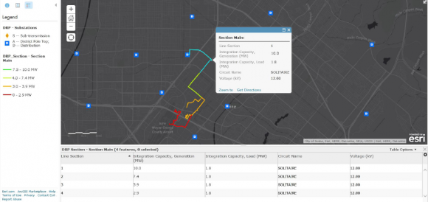
“For any distribution circuit, you’d see a map, and each circuit is divided into four segments,” he said. Each of the four segments has a different amount of DER that it can reliably handle, depending on whether it’s adding power to the circuit -- solar PV, demand response, or batteries in a state of discharge, for example -- or drawing power, largely in the form of EV or battery charging.
“It’s technology-agonistic, and it gives third parties a sense of how much capacity we have in both power-flow directions,” he said. “To the degree you can use this today, it can give a better idea for third parties looking to install these DERs, where they can locate without triggering any additional issues,” he said.
In a way, this is a bit like the “click-and-claim” concept that GTM contributor Tam Hunt laid out in an article last year, and it’s one of the key features that third-party DER companies like SolarCity have been asking for out of the DRPs. But it’s not all that they want. The next step is figuring out not just where DERs can be located without problems, but how they can play a positive role on the grid.

Building the costs and benefits of DERs into utility imperatives
That’s a more complicated calculation than simply setting maximum DER interconnection levels. In the DRPs, this next step is called Locational Net Benefits Methodology, or LNBM, Takayesu said.
CPUC’s guidance required all three utilities’ DRPs to unify their approaches to calculating these locational benefits, starting with an analysis of DER avoided costs (DERAC) provided by consultancy E3. Working with PG&E and SDG&E, as well as the nonprofit group More Than Smart, SCE came up with a framework for how it will calculate the costs and benefits of DERs across nine categories important to grid planners, he said. This chart from SCE’s presentation shows some of the key categories being measured.
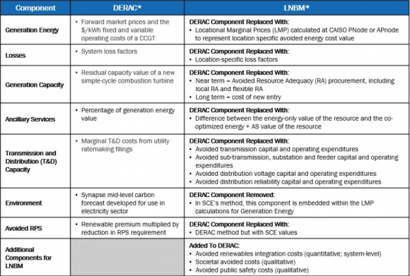
“We think that this framework will be useful in helping to identify, rank and prioritize locations where there will be net benefits,” Takayesu said. “There are some very specific categories -- one of the avoided cost categories is for avoided sub-transmission, substation and feeder capital expenditures,” he said.
There are also avoided distribution voltage and power quality categories, and others centered on DERs' effect on grid reliability and resiliency. “Then there are larger area types of categories, such as flexible resource adequacy, integration costs, societal avoided cost, and avoided public safety costs,” he said.
One of the most important categories to focus on is avoided capacity cost. “It really comes down to the integration into the utility's annual capital-planning processes,” he said. “Every year, we have an annual process where we forecast growth for our circuits and substations. We compare that forecast of demand to the rating of our facilities, and recommend least-cost solutions to meet that load growth.”
These least-cost solutions haven’t effectively included DERs as an option before. But under this new methodology, “we can compare projects that are potential candidates for DERs to have benefits, to understand what’s the most appropriate approach,” he said.
That’s a highly variable calculation, depending on the situation on individual circuits. As a recent UC Berkeley study pointed out, most distribution circuits aren’t at the point where they need immediate upgrades to handle peak daily capacity. But the few that are could see outsized benefits from DERs that reduce their peak loads, saving the utilities responsible for upgrading them a lot of money.
These planning efforts are part of a utility’s general rate case (GRC), which comes once every three years, each California utility taking its turn each year. SCE is filing its GRC next year, and “we are going to have a description about integration the DRP into the planning process, and mapping that to the general rate case,” he said.

Piloting the multi-technology DER gridscape
But even the relatively simple concept of capacity deferral gets complicated when the diversity of DER options comes into play. And that’s not including the more complex calculation of how all these multiple categories of values balance out, both at a local and system-wide level.
To get a better grasp of how this will work, SCE is launching five separate pilot projects over the coming years, each testing a different aspect of the DER integration puzzle, Takayesu said. It may be a bit ahead of its fellow utilities on this front, because it’s already deep into another pilot project that will serve as the foundation for these new DRP tests.
These existing projects are in Orange County, where SCE is facing significant long-term challenges to augment a grid that’s facing a double whammy in lost capacity: the closure of the San Onofre Nuclear Generating Station and the coming closure of seawater-cooled, natural-gas-fired power plants under state water regulations. Last year, Southern California Edison signed long-term procurement agreements for hundreds of megawatts of distributed energy resources to help meet these long-term capacity needs, tapping companies including Stem, SunPower, Advanced Microgrid Solutions, Ice Energy and NRG Energy.
Alongside that broader procurement, SCE set up a Preferred Resources Pilot (PRP), which is testing the ability of targeted energy efficiency, demand response, solar PV and energy storage to meet its local capacity needs. And within the PRP project boundaries is another pilot, funded by the state’s Electric Program Investment Charge (EPIC) program, dubbed the Integrated Grid Project.
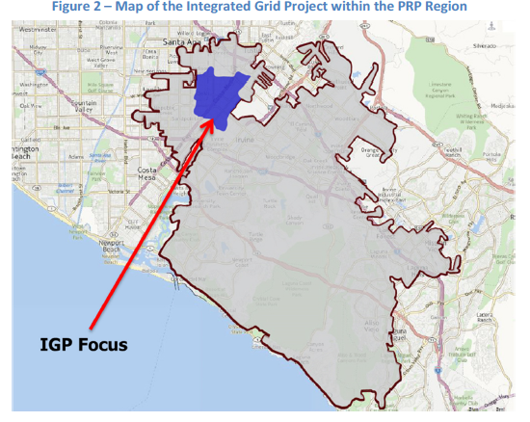
These projects will be testing several combinations of DERs and utility controls, he said. One will demonstrate how multiple types of DERs can be operated together to attain at least three of the avoided-cost categories that SCE has laid out. Another will integrate SCE’s distribution management system (DMS) with customer-owned, aggregated DERs. And a third will involve the creation of a microgrid that can manage its collective energy resources in a way that can allow it to “island,” or disconnect itself from the larger grid, while also helping the utility manage its grid needs.

How to pay for the DER-integrated grid
All of these projects will need to be paid for, as will future grid plans that take DERs into account. But for now, SCE hasn’t quantified those costs precisely. Instead, it’s asking the CPUC for permission to create a “Distributed Energy Resources Memorandum Account" (DERMA), which would record the revenue requirements for capital costs and operations and maintenance expenses from 2015 to 2017 that are to be added to its authorized funding.
“The ranges of investment that will be shown really represent moving from the technologies we’re deploying today to the next generation,” Takayesu said. Like its fellow California utilities, SCE has previously deployed smart meters, installed distribution automation gear, and invested in back-office software to support it all. Now it's seeking funding for an ongoing grid modernization.
“One of the things we envision is that the grid operator of the future is going to need to have the ability to make decisions on the grid,” Takayesu said. “They operate the grid 24 hours a day, they respond to emergencies, they reconfigure the system when maintenance is needed to balance load. As events occur, the ability to collect more information will drive feature evolutions in grid management systems.” SCE’s DRP includes an assessment of how these projects will help prepare the distribution system for higher penetrations of distributed energy, and where SCE may need to do more, he said.
Many questions still remain to be answered, however. One big one is how DERs might be compensated for serving a role in categories beyond their capacity value. California is still working on regulations for how DERs might be aggregated to serve the ancillary services needs of state grid operator CAISO, for example. Another CPUC proceeding is tackling how demand response -- controlling power consumption at homes and businesses to meet system-wide capacity needs -- might be further fine-tuned to help mitigate local grid constraints.
“One thing that the filing doesn't have in there is discussion about the details for future phases,” he said. “As we get out to the 2018-and-beyond timeframe, there are some paragraphs that discuss future visions of how the DRP will emerge in subsequent phases.”

