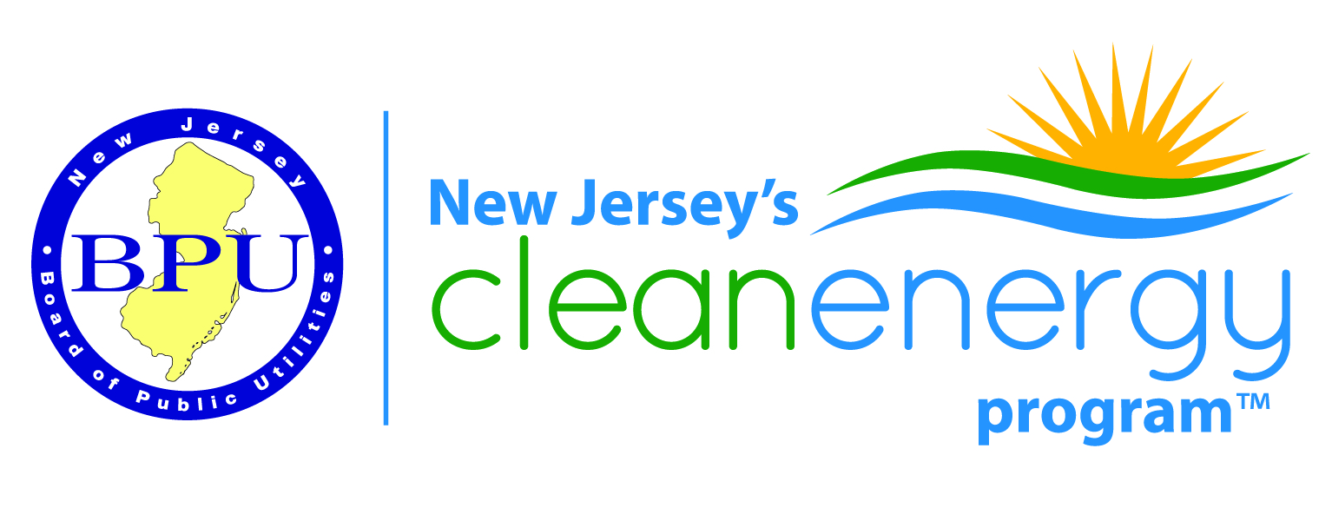
Renewable Energy Stakeholder Meeting
BPU 1st Floor Meeting Room - Trenton, NJ
February 14, 2017
1:00-3:30 PM
THIS IS AN IN-PERSON MEETING
Call in Number 888.273.3658
Access Code:7773306
AGENDA
Strategic Plan Discussion will take place from 2-3:30pm
Introductions
Regulatory Update (Marisa Slaten)

TRC Acquisition (Mike Ambrosio)

Update on the Solar Act (q, r, s, t) (Scott Hunter)

Interconnection Update (John Teague)

ACE Update (Josh Cadoret)

RE Electric Storage Entity Caps-Proposed Changes (Brendan Cassidy)
RPS Issues (Ron Jackson)
Contractor Remediation/Consumer Protection (Mike Ambrosio and Tom Kowalczyk)

Strategic Plan-Discussion (Mike Ambrosio and Jim Grevatt) 2-3:30pm

Other Business
Next Meeting -April 11th In-Person Meeting

