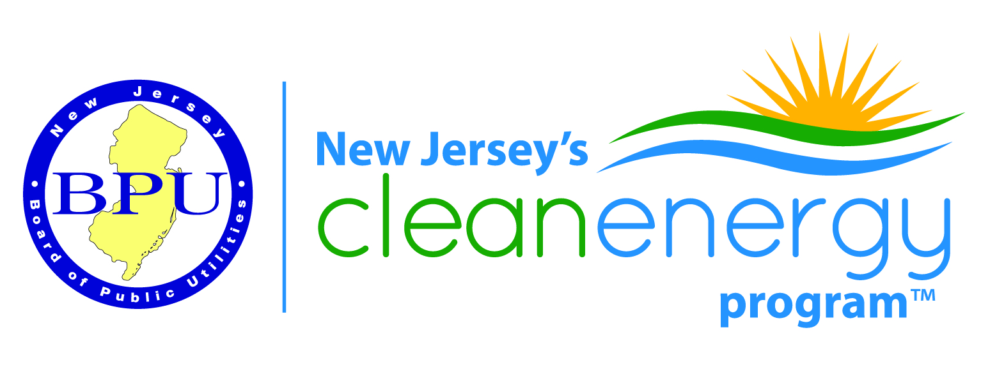
Renewable Energy Stakeholder Meeting
BPU 1st Floor Meeting Room - Trenton, NJ
June 13, 2017
1:00-3:30 PM
THIS IS AN IN-PERSON MEETING

Join by Phone
Toll-free number: +1 (877) 304-9323, access code: 6010862
Toll number: +1 (210) 606-9465, access code: 6010862

Conference ID: 6010862 (same as access code above)

For those participating by phone, please email your attendance to reattendance@NJCleanEnergy.com
AGENDA
Introductions
Regulatory Update (M. Slaten)

Update on the Solar Act (q, r, s, t) (B. Hunter)

Contractor Remediation/Consumer Protection Update (M. Ambrosio)

Interconnection Update (John Teague)

RPS Issues (Ron Jackson)
Other Business
Next Meeting Tentatively Scheduled for August 8th

