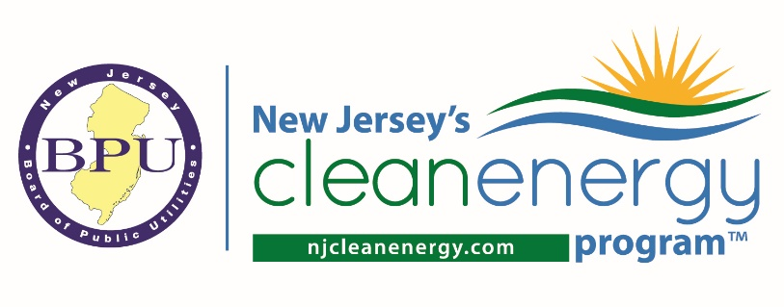
Energy Efficiency Stakeholder Meeting
October 19, 2023 | 1:00 – 2:30 PM
AGENDA

- Re-cap of Last Meeting
- New Jersey Energy Efficiency Programs
- Energy Efficiency Updates
  - NJCEP Updates
    - New Construction Program Update
    - Benchmarking Update
  - New Jersey Utility Updates
  - Regulatory Updates
    - Triennium 2 Filing Extension for Utilities
    - Evaluation, Measurement, and Verification Updates
- Guest Presentation – Comfort Partners
  - Frank Vetri – Energy Efficiency Program Manager, Elizabethtown Gas
  - Andrew Krigstein – Associate Program Manager, PSE&G
- General Q&A

