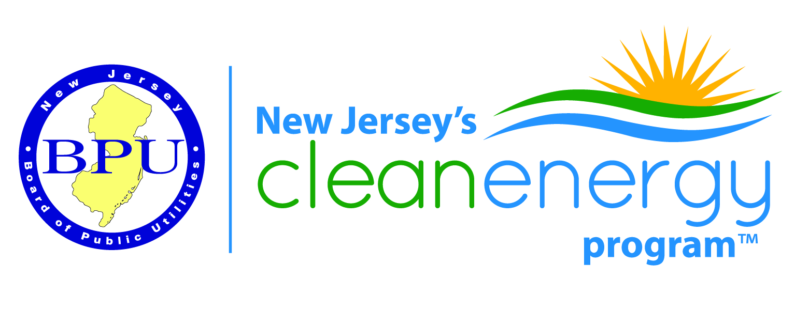
Renewable Energy Committee Meeting
BPU 1st Floor Meeting Room - Trenton, NJ
April 11, 2017
1:00-3:30 PM
THIS IS AN IN-PERSON MEETING
Join Skype Meeting
Join by Phone
Toll-free number: +1 (877) 304-9323
Toll number: +1 (210) 606-9465
Conference ID: 6010862

For those participating by phone, please email your attendance to reattendance@NJCleanEnergy.com
AGENDA
Introductions
Regulatory Update
- Strategic Plan
- FY18 Budgets
- CRA

Update on the Solar Act (q, r, s, t) (Scott Hunter)

Recommended Changes to Solar Reporting

Contractor Remediation/Consumer Protection Meeting Update

Interconnection Update (John Teague)

RPS Issues (Ron Jackson)
Other Business
Next Meeting -Tentatively Scheduled for May 9th

